

CLIK GETTING STARTED GUIDE
This document describes getting started with the Scaleform Common Lightweight Interface Kit. In addition to this document, users should familiarize themselves with the ‘CLIK Technical Appendix’.

Confidentiality

Copyright © 2008 by Scaleform Corporation and its licensors. All rights reserved.

No part of this documentation may be reproduced or transmitted in any form by any means, electronic or mechanical, including photocopying, recording, or any information storage and retrieval system, without the written permission of Scaleform Corporation.

Scaleform, the Scaleform logo, GFC, GFx, and the GFx logo are registered trademarks of Scaleform Corporation.

All other trademarks and registered trademarks are the property of their respective owners.

How to Contact Scaleform:

Document | Scaleform GFx 2.2 Scale9Grid User Guide
Address | Scaleform Corporation  6305 Ivy Lane, Suite 310  Greenbelt, MD 20770, USA
Website | www.scaleform.com
Email | info@scaleform.com
Direct | (301) 446-3200
Fax | (301) 446-3199

Authors: Michael Graves, Lanny McNie
Version: 1.00
Last Edited: February 4, 2009

Table of Contents

Confidentiality 2
Table of Contents 3
Overview 1
Setting up Flash to use Scaleform CLIK 1
Overview 1
Installation 1
Classpaths 2
Copy the classes into your project 2
Using the global classpath settings 3
Modifying a single document’s classpath 3
Intrinsic Classes 4
Best Practices 4
Skin Component Set 4
Overview 4
Basic Components 4
Button (gfx.controls.Button) 4
CheckBox (gfx.controls.CheckBox) 6
RadioButton (gfx.controls.RadioButton) 6
Label (gfx.controls.Label) 6
TextInput (gfx.controls.TextInput) 6
TextArea (gfx.controls.TextArea) 6
ScrollIndicator (gfx.controls.ScrollIndicator) 6
ScrollBar (gfx.controls.ScrollBar) 6
Advanced Components 7
ButtonBar (gfx.controls.ButtonBar) 7
DragTarget (gfx.controls.DragTarget) 7
InventorySlot (gfx.controls.InventorySlot) 7
ItemSlot (gfx.controls.ItemSlot) 7

NumericStepper (gfx.controls.NumericStepper) 7
Slider (gfx.controls.Slider) 7
StatusIndicator (gfx.controls.StatusIndicator) 7
ProgressBar (gfx.controls.ProgressBar) 7
UILoader (gfx.controls.UILoader) 7
ViewStack (gfx.controls.ViewStack) 8
List-based Components 8
ScrollingList (gfx.controls.ScrollingList) 8
TileList (gfx.controls.TileList) 8
DropdownMenu (gfx.controls.DropdownMenu) 8
Dialog (gfx.controls.Dialog) 8
Tween (gfx.motion.Tween) 8
Manager Classes 9
FocusHandler (gfx.managers.FocusHandler) 9
InputDelegate (gfx.managers.InputDelegate) 9
PopUpManager (gfx.managers.PopUpManager) 9
DragManager (gfx.managers.DragManager) 9
GameDelegate (gfx.io.GameDelegate) 9
Component Instantiation & Initialization 9
Overview 9
Class Structure 9
Creating Custom Components 10
Adding Components from the Library 10
Adding Components using ActionScript 10
Component Parameters 10
Best Practices 10
Creating Components 10
Overview 10
Editing the Default Components in Flash 11
Creating Skin Components from Scratch 11
Instructions: 11
Skinning CLIK Components 12

Enabling the Component Parameters 13
Component States 14
Creating animated states 15
Special Cases 15
Scaleform Launch Panel 15
Overview 15
Installation 15
Setting up Players & Profiles 15
Player Name vs. Profile Name 16
Mac vs. Windows Players 16
Command Line Parameters 16
Example 16
Commands & Shortcut Keys 16
Scaleform Component Creator 16
Overview 16
Best Practices 17
Extending ‘Skin’ Components (Samples) 17
Overview 17
Best practices: Packages 17
Clean-up and disposal 18
Common methods and properties 18
Fonts 18
Overview 18
Embedding Fonts 18
Embedding Fonts in a TextField 19
Creating Font Symbols in the Library 19
Example 19
Runtime Shared Libraries (RSLs) 19

Overview
The Scaleform CLIK (Common Lightweight Interface Kit) Framework is a purpose built set of ActionScript 2 components, libraries, and workflow enhancement tools to help Scaleform GFx users quickly implement user interfaces for console and PC games. The core goals of the framework are to make it lightweight (in terms of memory and CPU usage), easily skinnable, simple to extend and highly customizable.

Due to the highly dynamic and custom nature of game UIs, this component set was developed as a flexible foundation for development, rather than as a comprehensive, rigid component set that will meet the requirements of most UIs out-of-the box. As such, it is fully expected (and encouraged) that you will extend and modify the framework code to meet your specific needs. Every effort has been made to make this process intuitive and straightforward.

This user guide covers a number of important high-level topics regarding the use of the Scaleform CLIK Framework. In addition to this user guide, we have also provided full API documentation, and a variety of samples to show how to get common use cases working. For additional technical details on component states, focus handling, input capture, the event model, localization, invalidation, dataProvider, and component scaling, refer to the Scaleform CLIK Technical Appendix.

Setting up Flash to use Scaleform CLIK

Overview
The Scaleform CLIK Framework is built in ActionScript 2, and optimized for use in Adobe Flash 8 and CS3. The framework uses Flash 8 features such as Scale9Grid and geometry classes that make it incompatible with Flash 7 (MX 2004, MX 2004 Professional).

Installation
Scaleform CLIK workflow enhancement tools (Flash panels, JSFL commands) such as the Scaleform Component Creator (see ‘Scaleform Component Creator’) and the Scaleform Launcher (See ‘Scaleform Launch Panel’) can be installed by running the supplied MXP files. To install these tools in Flash CS3 or Flash 8, use Adobe Extension Manager. To install these tools in Flash CS4, use Adobe Extension Manger CS4. After installation, you will need to relaunch Flash in order for your changes to take effect. Installed panels will be accessible in the Flash IDE by choosing Window > Other Panels > PanelName. Installed JSFL commands will be accessible under the Commands Menu.

To install all the workflow enhancement tools at once, simply run the MasterName.mxp. If the a panel is already installed, it may prompt you to overwrite the existing installation, however any preferences or settings will not be overwritten.

There is no installation required to use Scaleform CLIK components. The components are not converted into compiled components in order to allow developers easy access to edit the timelines of the assets (simply double click a component to edit like a regular Flash symbol). To use them, simply copy the desired component(s) from the “CLIK_Components.fla” library, to the library of your working FLA, and ensure that your document’s (or the global) classpath is configured to point at the folder containing the gfx.* package (see ‘Classpaths’). Alternatively, you could choose to gain access to the components by setting up a runtime shared library (RSL) to share component assets across multiple swfs (see ‘Runtime Shared Libraries’).

Also supplied is a Scaleform CLIK Template FLA, that contains all the components in the library. Creating new documents from this template will give you a blank FLA, with all the CLIK components in the library. To install this template, place “CLIK_Components.fla” in the “Templates” Directory located at (Mac Path / Windows Path). After doing so, you can generate a new document from this template by choosing File > New > Templates, and then select Scaleform > CLIK_Components.

Classpaths
A “classpath” is a directory path where ActionScript classes reside. By defining a classpath, you make ActionScript classes available to your FLAs. This section describes how to set up your classpath to point at the folder containing the gfx.* package (the gfx.* package contains all the ActionScript classes required by the component framework).

The Scaleform CLICK framework classes are all stored in the gfx.* package. The gfx folder containing the framework code needs to be stored relative to FLAs that are created. If the files reside elsewhere, ensure that the document classpaths point to the directory containing the gfx.* package, or a global classpath is set up to point to that directory. Note that if the files are shared with other users, they each will have to set up their classpaths for their local Flash application. Both these techniques are described in detail below.

Copy the classes into your project
Place the gfx.* package in the same directory as the FLAs (on the same level). There is a default global classpath of “.” which has the benefit of not needing to modify any classpaths, and allows you to store modified versions of the ActionScript classes per project (not necessarily the recommended approach).

Using the global classpath settings
To modify your global classpaths in Flash so any new FLA will be able to import gfx.* classes, choose:
Edit > Preferences (On the Mac: Flash > Preferences).
Select ActionScript > ActionScript 2.0 Settings.
Click the “+” to add the path to the directory that contains the gfx.* package.
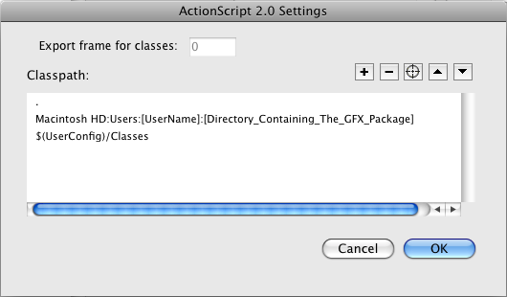
Important: Ensure that the classpath you add is before the Flash classpath $(UserConfig)/Classes. For more information, see the ‘Intrinsic Classes’.

Modifying a single document’s classpath
To change your classpaths for a single document so a FLA will be able to import gfx.* classes, choose:
File > Publish Settings
Select the Flash tab and click ActionScript 2.0 Settings.
Click the “+” to add the path to the directory that contains the gfx.* package. Note that modifying a single document’s classpath likely will cause errors when the FLA is compiled on another computer. The document classpath would need to modified in order for it to point at the correct local directory. There is no need to set up a single document's classpath if you have already defined a global classpath.

Intrinsic Classes
The GFx player contains several APIs not found in the Flash player. Usually, these methods need to be accessed using square brackets to bypass the Flash compiler, however the component framework contains an updated set of intrinsic classes, which instruct the compiler to include the GFx APIs. These classes are found in the same directory that contains the gfx.* classes. It is important to ensure that these intrinsic classes are included before Flash’s default intrinsic classes.

Important: If you set up a global classpath (see ‘Classpaths > Using the global classpath settings’), ensure that the CLIK component classpath (the path to the gfx.* package) is before the default Flash classpath, which is $(UserConfig)/Classes.

Best Practices
Our recommendation is to place the gfx.* package in a known location on your computer, and add that directory as a global classpath. When sharing FLAs and projects with other developers, each developer will require a global classpath set up on their own machine, otherwise FLAs using CLIK components will not compile.

Skin Component Set

Overview
This section includes the full list of developer components, contained in the gfx.* package.

Basic Components

Button (gfx.controls.Button)
The foundation component of the framework, Button components are used anywhere a clickable interface control is required. The default Button class supports a textField to display a label, and states to visually indicate user-interaction. Buttons can be used on their own, or as part of a composite component, such as ScrollBar arrows or the Slider thumb. Most interactive components that are click-activated compose or extend Button.

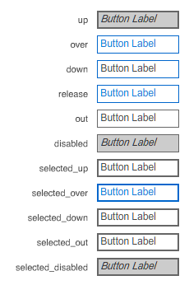
Default Button Skins:

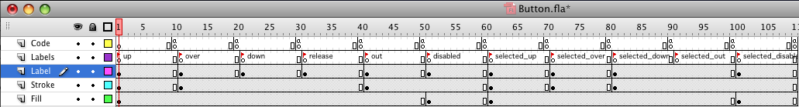
Default Button Timeline:

For a comprehensive description of Button States, see 'Component States', in the Technical Appendix.

Nested (composite) Instances:
- textField: A Textfield instance with this name will get populated by setting the Button.label property

Default Inspectable Properties:
- autosize: Deteremines if the Button scales to the size of its label
- label: The text label of the Button
- toggle: Determines if the Button toggles its selected state when clicked.

CheckBox (gfx.controls.CheckBox)
A Button component that is set to toggle the selected state when clicked. CheckBoxes are used to display and change a true/false value.

RadioButton (gfx.controls.RadioButton)
A Button component that usually belongs in a set of Buttons used to display and change a single value. Only one RadioButton in a set can be selected at one time, and clicking any Button sets it to the selected item in the set.

Label (gfx.controls.Label)
A non-editable text label. Label components provide a way to create and modify a specific label style, where one component can be styled a single way, and used across an application many times. Labels also support a built-in localization approach for id-based translation. (see Localization in the Technical Appendix)

TextInput (gfx.controls.TextInput)
An editable TextField component, used to capture textual user input.

TextArea (gfx.controls.TextArea)
An editable TextField component that supports multi-line text and an optional ScrollBar. The TextArea also includes all the functionality of TextInput (above).

ScrollIndicator (gfx.controls.ScrollIndicator)
Displays the scroll position of another component, such as a list or TextField. The ScrollIndicator can be pointed at a TextField to automatically display its scroll position. All list-based components as well as the TextArea have a scrollBar property which can be pointed at a ScrollIndicator or ScrollBar instance or linkage.

ScrollBar (gfx.controls.ScrollBar)
Displays and controls the scroll position of another component. The ScrollBar adds interactivity to the ScrollIndicator with a draggable thumb button, as well as optional “up” and “down” arrow buttons, and a clickable track.

Advanced Components

ButtonBar (gfx.controls.ButtonBar)
Displays a set of buttons that belong to a group, similar to RadioButtons. The buttons are created using a dataProvider property, and laid out horizontally or vertically (see DataProvider).

DragTarget (gfx.controls.DragTarget)
Acts as a target for drag operations initiated with DragManager. While the usefulness of this class is limited, it provides a simple example for working with DragManager, and is the basis for the InventorySlot and ItemSlot components.

InventorySlot (gfx.controls.InventorySlot)
Displays an inventory "item" with quantity, and uses DragManager to allow dragging and dropping items between InventorySlots with compatible dragAcceptTypes.

ItemSlot (gfx.controls.ItemSlot)
Requires Description.

NumericStepper (gfx.controls.NumericStepper)
Displays a numeric value in a range, with buttons to increment or decrement the value. Usage.

Slider (gfx.controls.Slider)
Display a numerical value in a range, with a thumb to represent the value, as well as modify it via dragging. Usage.

StatusIndicator (gfx.controls.StatusIndicator)
Displays a percentage value as a position on the component’s timeline. This component can be used to display any sort of percentage, such as a life or time meter.

ProgressBar (gfx.controls.ProgressBar)
The ProgressBar extends the functionality of a StatusIndicator adding the ability to monitor a target to determine its value. This component is typically used to display a increasing or decreasing percentage such as load time, or time left.

UILoader (gfx.controls.UILoader)
Load an external SWF or image using only the path. UILoaders also support auto-sizing of the loaded asset to fit in its bounding box.

ViewStack (gfx.controls.ViewStack)
Load and optionally cache different views, displaying only a single view at a time. This component can be used for multi-view components such as a TabBox, or Accordion (samples of each of these examples can be found in the demos folder). A ViewStack can also be pointed at another component such as a RadioButton group to automatically change views when the component changes.

List-based Components
All list-based components are populated using a DataProvider. For more information, see ‘DataProvider’.

ScrollingList (gfx.controls.ScrollingList)
A list of items with an optional vertical ScrollBar, commonly used to represent a list of textual items. The ScrollingList supports a single selected item.

TileList (gfx.controls.TileList)
A list of items displayed in a grid, that can be scrolled horizontally or vertically (but not both). The TileList supports a single selected item.

DropdownMenu (gfx.controls.DropdownMenu)
A Button component that displays a dropdown when it is clicked. The dropdown can be any component that implements the IList interface, such as ScrollingList or TileList, which displays the list of items, and can change the selected item.

Dialog (gfx.controls.Dialog)
Displays a dialog view, such as an Alert dialog, on top of the rest of the Application. The Dialog class provides a static interface to instantiate a show and hide a MovieClip as a dialog, as well as a base class that can be used (or extended) as the actual dialog MovieClip. Only a single dialog can be open at once, and new Dialog.show() calls will close the currently open dialog.

Tween (gfx.motion.Tween)
The Tween class can be initialized once to add tweening capabilities to any and all MovieClips. The tween methods can be used to change any numerical property over time, such as animating its size and position, or changing its value.

Manager Classes

FocusHandler (gfx.managers.FocusHandler)
The FocusHandler manages the application’s focus, or component that has user focus. The component framework only supports a single point of focus, to which all user interaction is automatically directed. For detailed information on focus, see ‘FocusHandler’.

InputDelegate (gfx.managers.InputDelegate)
The InputDelegate intercepts all user input such as keyboard or controllers, and translates the interaction into understandable data, which is sent out through the FocusHandler. For detailed information on handling user input, see ‘InputHandler’ in the Technical Appendix.

PopUpManager (gfx.managers.PopUpManager)
Display a MovieClip or component as a pop-up, which is added to the top level of the application instead of in the scope that called it. The PopUpManager is used by the framework to display things like tooltips, dialogs, dropdowns, or any other content that should be displayed over top of the other application items.

DragManager (gfx.managers.DragManager)
Create and manage drag and drop interactions. Usage.

GameDelegate (gfx.io.GameDelegate)
All interaction between the Flash/GFx application and the Game runs through the GameDelegate class. The GameDelegate provides a single point of management for game engine interactions so that the entire communication mechanism resides in one place, rather than scattered throughout the Flash application. For more information, see ‘GameDelegate’ in the Technical Appendix.

Component Instantiation & Initialization

Overview
All components are supplied as un-compiled MovieClips (regular Flash Symbols bound to ActionScript Classes). Components can be instantiated by being dropped on stage from the library, or created dynamically with ActionScript (using the ActionScript 2 attachMovie() syntax). The supplied components also come with component parameters for easy set-up and testing.

Class Structure
All the interface components extend UIComponent, or a sub-class of UIComponent (gfx.core.UIComponent). UIComponent implements methods and properties to handle all the common functionality that the interface components share, including initialization, configuration, invalidation, and some utility functions found in multiple components.

Creating Custom Components
Custom symbols can be converted into components by adding a class in the Symbol Linkage dialog. For instance, adding the linkage “gfx.controls.Button” to any symbol will cause it to behave like a Button component (given your classpath is set up correctly. See ‘Classpaths’). The Component Creator panel can be used to set up the component states (see ‘Component Creator’), and automatically assign the appropriate linkage.

Adding Components from the Library
Simply drag and drop symbols from the library (or another FLA’s library) to the stage to use them. Add an instance name in the properties panel to reference them dynamically with ActionScript.

Adding Components using ActionScript
Components can be instantiated with ActionScript by using the ActionScript 2 “attachMovie” syntax. (The component must be located in the FLA library that uses this code in order to instantiate it).
var myButton:Button = attachMovie(“Button”, “instanceName”, depth);

Component Parameters
Most components have a set of properties that can be easily edited in the Flash IDE. For instance, if you select a Button instance on the stage and open the Component Inspector panel, (Window > Component Inspector), or the Parameters panel (Window > Parameters), you can modify the label property without the need to write any ActionScript. To enable component parameters on custom components, see ‘Enabling Component Parameters’.

Best Practices
Our recommendation is to avoid using component parameters in order to keep all of the logic that controls an instance encapsulated in an ActionScript file, and not scattered across an FLA and ActionScript files. However, from a designer’s perspective it is sometimes useful to see the effects of modifying component parameters in the FLA. The important thing is to be consistent with the rest of the team.

Creating Components

Overview
The components shipped with the Scaleform package are known as the “default” components. Any MovieClip can be given the appropriate gfx.* linkage to make it behave as a component. The default components are just a pre-packaged set with a default skin and component parameters already set up. The components can be created from scratch easily, or the default set edited.

Editing the Default Components in Flash
Once the components have been added to a Flash library, the symbols can be edited directly. Any instances using the edited component will use the edited skins. To add another component of the same type, but with a different skin, the existing component can be duplicated or another created from scratch. To duplicate a component, right-click the symbol in the library and choose “Duplicate”. Ensure that the “Export for ActionScript” and “Class Name” are set properly, as those values are not populated by default.

Creating Skin Components from Scratch
A new symbol can be created, and the correct linkage assigned to create a component from scratch. For example, any symbol with the gfx.controls.Button linkage will take on the Button behaviors.

Instructions:
To create a new symbol in the library, or using existing stage assets:
- Edit the “linkage” dialog, enable “Export for ActionScript”, and enter “gfx.controls.Button” in the “class” field.
- Edit the symbol and add the appropriate state frames and assets. Note that a Button component has an optional TextField (with an instance name of “textField”), which is populated with the label property of the Button. This asset is not automatically created.

As long as the component classes are relative to the document, or the classpaths set correctly (see ‘Classpaths’), your new symbol will now behave like a Button Component.

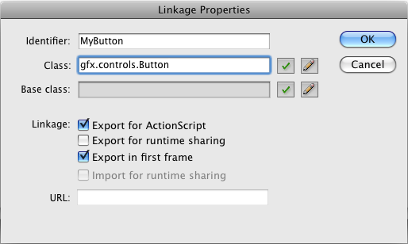

Skinning CLIK Components
The Scaleform CLIK Component set is as easy to skin as any regular Flash symbol. Simply double-click a component in your FLA's library to gain access to its timeline and:
- modify the default skins in Flash
- create your own skins from scratch in Flash, or
- import assets into Flash using the numerous types of files that Flash supports

For instance, some designers may wish to design all of their component states on seperate layers in Adobe Photoshop or Adobe Illustrator, and then import the PSD or AI file onto the stage in a components timeline. By taking advantage of Flash's import dialog, designer's can specify that their AI or PSD layers get converted to keyframes upon import.
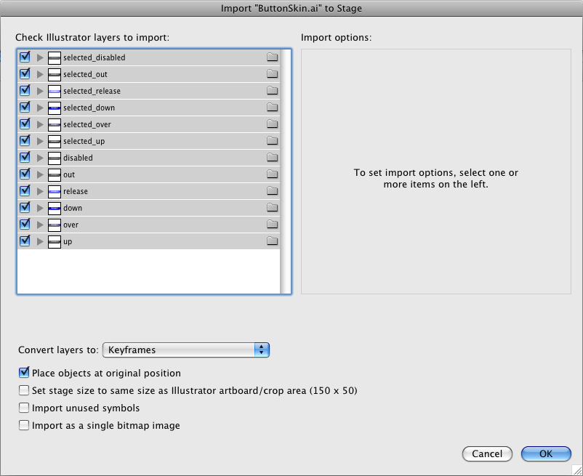

By placing the each imported keyframe under the appropriate frame label, the CLIK framework will ensure that the correct skin appears when that state is activated.

If you are creating your component skins in Adobe Photoshop, we recommend that TextFields are created directly in Flash. Since TextFields must exist on their own layer in Adobe Photoshop, using the technique described above will cause additional keyframes to be created upon import (if you are converting layers to keyframes).

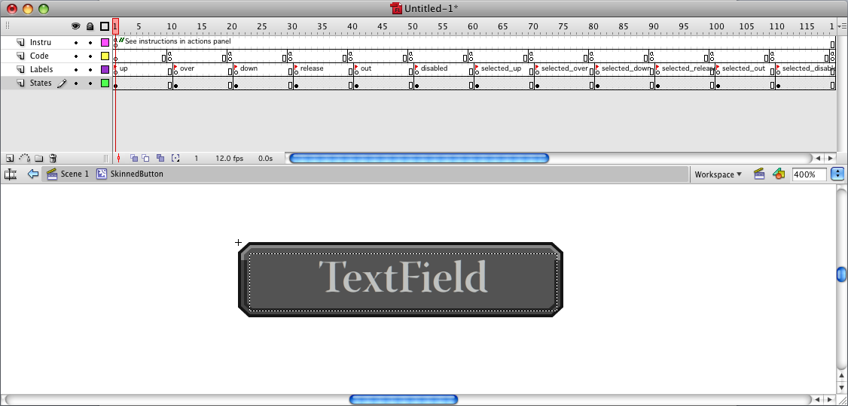

Enabling the Component Parameters
Most components in the Skin component set have a set of component parameters, which enable custom properties of a component instance to be set without using ActionScript. Component parameters are defined in the source code using Inspectable() meta-data above the repective method, and a list of inspectable methods that a component exposes is defined in an InspectableList() meta-data at the top of the class file. To change the parameters of a component instance:
- Select the component on stage.
- Open the Parameters panel by choosing Window > Parameters. The Component Inspector panel offers additional parameters, which can be opened by choosing Window > Component Inspector.

When creating components from scratch, the component parameters will not be accessible. To enable the component parameters on new components:
- Right-click the symbol in the library, and choose “Component Definition”.
- Enter the class path into the “class” input field.
- Click OK. The component parameters are all added automatically.
- Open Window > Component Inspector to modify the parameter values.

As long as the component classes are relative to the document, or the classpaths set correctly (see ‘Classpaths’), all of the component’s parameters will be applied, and any instances of that component will have those parameters available.

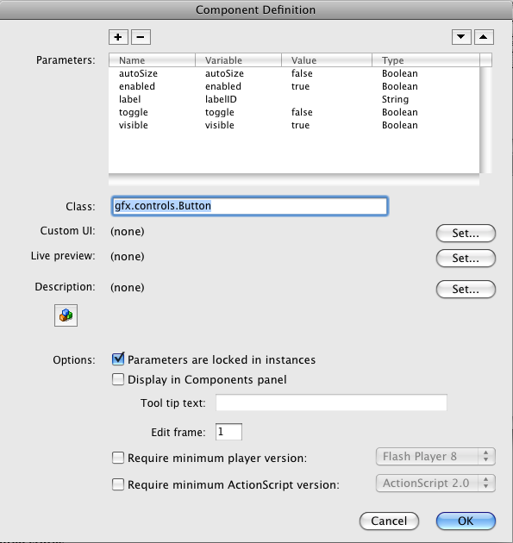

For more information on component parameters, and the Inspectable meta-data, please consult the Adobe Flash Help.

Component States
Almost all components support visual states. States are set up by navigating to a specific keyframe in the component timeline, or passing state information onto sub-elements. For additional information, see Component States in the Technical Appendix.

Creating animated states
The component framework uses gotoAndPlay() to set states when state changes are made. This enables designers to add animated states out-of-the-box. Each state should have a corresponding stop action at least one frame after the frame label (and not on the same frame as the label). The timeline created by the Component Creator panel (see ‘Component Creator’) will generate a 10-frame space between frames and labels, which an animation can be put on. This duration can be safely edited in the timeline, given there is a stop() action on the desired end position keyframe.

Special Cases
There are some components which do not abide by the ‘state’ rules described above.
StatusIndicator, and the extended ProgressBar demo component use the timeline animation to display the value of the component. The playhead will be set to the frame that represents the percentage value of the component. For instance, a 50-frame timeline in a StatusIndicator with a minimum of 0, a maximum of 10, and a value of 5 (50%) will gotoAndStop() on frame 25 (50% of 50). It is fairly simple to extend these components to manage the display programatically. The updateValue() method can be modified or overridden to change this behavior.

Scaleform Launch Panel

Overview
The Launch Panel is a workflow tool to test SWF content in the Scaleform GFx player directly from the Flash IDE.

Installation
The Launch Panel is included in the Workflow Tools MXP (See ‘Installation’). Once the MXP has been installed, the panel is available in Window > Other Panels > Scaleform Launcher. To test a movie, add a profile, ensure a GFx or other player is installed and configured, and click “TEST in [player name]”. Each of these steps are described in detail below.

Setting up Players & Profiles
A profile is a saved list of settings. Settings include a target executable (GFx player), and optional additional command line parameters. You need at least one profile to test content. To add a profile, click the + button next to the profile list. Enter a profile name, and select a player from the list. If no players have been installed, click the + button next to the dropdown, and browse to the player application you wish to use. You may need to give the player a name if it cannot be determined automatically. It is recommended to include the version number in the player name.

Player Name vs. Profile Name
A player defines an executable on your system used to test SWF content. Usually, this will be a GFx player release, downloaded as part of the GFx SDK, however it can also be a custom player or workflow. A profile defines a specific test-case, with a selected player and command-line argument(s).

Mac vs. Windows Players
Find the GFx installation package on your computer, and browse to Bin/<os>/GFXPlayer.exe. On OS X, you will need to also browse to /Contents/MacOS/FXPlayer.

Command Line Parameters
Optional parameters can be passed to the command line when launching a player. In each profile there is a command line field, where the different options can be filled in. By default there is a %SWF_PATH% argument, which is replaced by the exported SWF path.

Example
To open the GFx player without the loading the Gfx hud into the GFx player instance (usually F12 in GFx):
%SWF_PATH% -nh

Commands & Shortcut Keys
A command is installed with the MXP that can invoke the TEST action in the Launch panel. It can be found in the Commands > Publish in GFx Player menu. A key can be bound to this command by modifying the key bindings in Flash. The command will only work if the Launcher panel is open. For additional information on modifying shortcut keys in flash, visit this article on Adobe.com.

Scaleform Component Creator

Overview
The Scaleform Component Creator Panel provides an easy way to convert an existing MovieClip to a Scaleform component. Select a symbol in the library or on the stage, choose the type of component in the dropdown menu in the panel, and click OK. The correct linkage is applied to the symbol in the library, and the timeline is set up with the correct labels and actions (to support the various states). Existing assets are left untouched, and an instructions layer is populated with some general guidelines for the component. Open the actions panel and select the first keyframe on the instructions layer to read the generated instructions.
The Component creator panel does not ensure that the classes are present, so you will have to make sure that is already set up (see ‘Classpaths’). Additionally, component parameters are not added automatically. To enable component parameters, see ‘Enabling Component Parameters’ after the component is created.

Best Practices
It is advisable to set up the component before creating or importing its assets. If the component already has the frames set up, running it again will duplicate them, so the Component Creator will check if the component already has the specified linkage on it, and will prompt the user to confirm the operation. Using the Component Creator is not a required step, it simply automates the task of setting up symbol linkage, frame labels and actions in the symbol’s timeline. It also generates useful instructions in the symbol’s timeline.

Extending ‘Skin’ Components (Samples)

Overview
Extending an existing component is a 3-step process:
- Create a new component skin or symbol using the steps defined in “Creating Components”.
- Create a class that extends the component that you wish to extend. (Ensure that the super class is imported, and that the super() method is called in the constructor). Methods that exist in the super class that are overriden should make a call to super.methodName() where appropriate.
- Attach the new class linkage to your component.

Example:
import gfx.controls.Button;
class ToggleButton extends Button {
public function ToggleButton() {
super();
toggle = true;
}
}

Best practices: Packages
New classes should not be created in the gfx.* package. Instead, a package should be created reflecting the game for game-specific classes, or your company for general-use components that will be used in multiple games, For example:

masseffect.controls.SpecialComponent
com.bioware.controls.SpecialComponent
We recommend the reverse-domain naming approach for company-based classes, but for specific game use, a classpath like the masseffect one above is sufficient. It is mainly important to use a unique name that is relevant, and unlikely to collide with another project or class.

Clean-up and disposal
Components extending gfx.core.UIComponent, or any sub-class, will call cleanUp() automatically any time removeMovieClip() is called. Components should implement the cleanUp() method when appropriate to remove sub-components, listeners, and clean up other elements, and ensure that a call to super.cleanUp() is always made.

Common methods and properties
Throughout the component framework, there are several common private methods used. It is important to call the superclass’ method where appropriate.
configUI(): After the onLoad() method, configUI() should be used to set up UI elements and listeners. The configUI() method is called automatically in any component extending UIComponent.
draw(): Any time a component property has changed requiring a redraw, draw() is called after invalidation. See ‘Invalidation’ for more information.
changeFocus(): The focus for that component has changed. The changeFocus() method should change the visible state of the component to reflect the focused property.

Fonts

Overview
In order for fonts to render correctly in GFx, the required glyphs (font characters) must be correctly embedded in your swfs. The following area explores various ways of achieving this.

Embedding Fonts
Unlike the Flash Player, GFx requires fonts to be embedded properly for them to show up, and will display small rectangles if they are not embedded, even if they reside on the system. The benefit of this is you can easily see if your fonts are embedded correctly in GFx. In the default component set, Arial is embedded in each TextField instance.

There are 2 ways to embed fonts in an swf (described in detail below). You can adjust the embedding options on a textField instance on the stage or you can create Font Symbols in the library. Additionally, you can use Runtime Shared Libraries (see ‘Runtime Shared Libraries’) that make use of Font Symbols in the library to share fonts across multiple swfs without embedding the fonts multiple times, potentially bloating the file-size and memory usage for text.

Embedding Fonts in a TextField
You only need to embed fonts in dynamic or input textFields. Static text is automatically converted to outlines (raw vector shapes) when you compile. To embed a font in a dynamic textField, select the textField on the stage and click the “Embed” button in the property inspector (Window > Property Inspector). Choose the characters, or character sets you would like to embed and choose “OK”. Once you have completed those steps, the font will be available for use in your FLA. You only need to embed a font this way once if the same font is used in multiple textFields in the same FLA. Conversely, embedding it multiple times will not increase the filesize or memory usage.

Creating Font Symbols in the Library
Another way to embed a font in your swf is by creating a Font Symbol. You can do this by right clicking in the library panel and choosing “New Font”. Give your library symbol a name, choose the font you would like to embed and optionally apply faux bold, faux italic, bitmap text and point size. The point size is only required if you are choosing bitmap text. The next step is to export your Font Symbol for ActionScript so it will be available to textFields at runtime. Right-click your font symbol in the library and choose ‘Linkage’. Click “Export for ActionScript” and choose “OK”.

Once your Font symbol is set up, you can apply that font to a textField on the stage normally without the need to additionally embed the font on any stage instances. Additionally, you can programatically assign that font to a textField by using a TextFormat object (ensure that your textField instance has embedded fonts.

Example
myTextField.embedFonts = true;

Either of the techniques described above will work for simple scenarios. Projects that require robust international support, or make use of multiple swfs that need to access the same fonts, may wish to make use of Font Symbols in the library, and have them exported as runtime shared library items (described below).

Runtime Shared Libraries (RSLs)
Often it is desirable for multiple swfs have access to a centralized library of assets to reduce the overhead and maintenance of having duplicate assets compiled into multiple swfs. An excellent example is fonts. A project need not have a single font embedded in every swf that is loaded into a game. The same goes for a common button. If numerous swfs have button symbols that all share the same aesthetic, it is desirable to only embed that asset in one place. This benefits asset management, file size, and memory usage. The mechanism to address this workflow is called Runtime Shared Libraries (RSLs).

In order to make a library asset available to other swfs, you must specify that the symbol is exported for runtime sharing. You can do this by right clicking the library symbol, and choosing “Linkage...”.

In the Linkage dialog, check “Export for runtime sharing” and specify the URL to the swf that will compile from that FLA (the same url as the swf in your publish settings). When you compile that FLA, the exported symbol(s) will be made available to load into other swfs from the one you just compiled.

After you have set up a symbol to Export for Runtime Sharing, you can copy and paste, or drag and drop that symbol from the source library, to another FLA’s library, and Flash automatically specifies that the pasted symbol is to be Imported for Runtime Sharing. This means that the symbol that was copied in is not actually stored in the destination FLA, but it will instead import that symbol at runtime from the swf located at the URL specified in the Linkage dialog.

You don’t need to copy and paste the library symbol from one FLA to another. Instead, you can create a new symbol from scratch, and manually set up the linkage and importing options in the Linkage dialog for the new symbol. The important things to keep in mind is that both symbols must have identical linkage names, and must both be pointed at the source SWF in the URL field. You can only edit the symbol in the FLA that is exporting it for runtime sharing. If you make edits to this symbol, you will need to recompile the FLA that is exporting that symbol. Additionally, if the source symbol is bound to ActionScript classes, and there are edits to the ActionScript classes, you will need to recompile the source swf.

If you wish to have a live preview of a symbol that is set up to import for runtime sharing, you can use Adobe Flash CS4 to go through the additional steps of navigating to the source FLA, and specifying the symbol which you would like a live preview of. Dynamic Live Previews, such as those found in the Adobe CS3 components are possible, however there are quite a few steps to achieve a useable preview, and the behavior is not always optimal. As such, this process is not documented here.

